1. 超声波测距

* 实验所需材料：

Arduino 2560、超声波模块

* 连接示意图

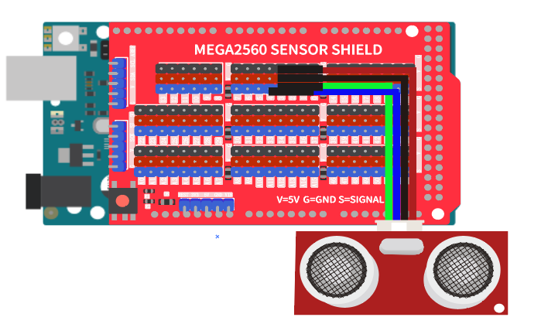

|  |
| --- |
| /*  OpenJumper LEDModule  www.openjumper.com  */  volatile float dis;  float checkdistance_3_4() {  digitalWrite(3, LOW);  delayMicroseconds(2);  digitalWrite(3, HIGH);  delayMicroseconds(10);  digitalWrite(3, LOW);  float distance = pulseIn(4, HIGH) / 58.00;  delay(10);  return distance;  }  void setup(){  dis = 0;  pinMode(3, OUTPUT);  pinMode(4, INPUT);  Serial.begin(9600);  }  void loop(){  dis = checkdistance_3_4();  Serial.println(dis);  } |